**"Must Have It"**

**(30 Total Points)**

Search new gadgets on the Internet and find one that you would like to have. The gadget has to have a clear link to technology, but it doesn't have to be a computer.

Next, do some research on the gadget and create an advertisement for it. Some examples formats for your advertisement are poster, brochure, flash animation, or video. If you can think of something else that you can submit digitally, it is fine as long as I am able to grade it.

*\*Be sure to use software that I have so I am able to grade it.*

The ad must contain the following information: **(3 pts each)**

1. The name of the gadget.
2. The price of the gadget.
3. A picture of the gadget.
4. What the gadget does.
5. What makes the gadget a "Must Have It"

The additional **15 possible points** will be based on things like:

     Is it neat? Is it colorful if appropriate? Is it your work or did you primarily cut and paste? Does it make me want the gadget? ...

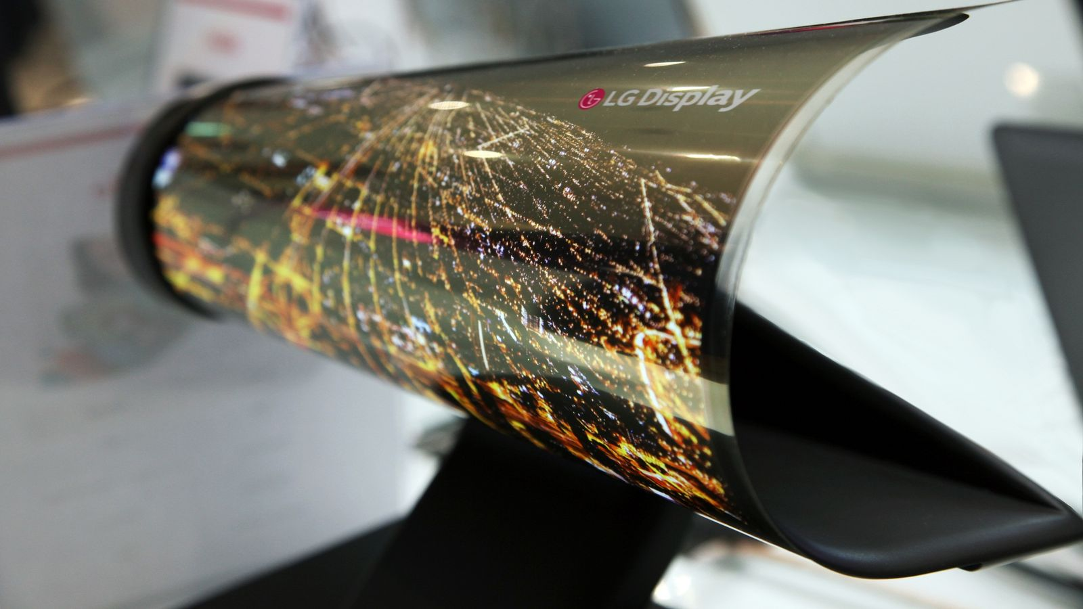

The LG Rollable OLED conveniently rolls up making it a must have

The LG Rollable OLED for only **4,497.00**

THE FUTURE IS HERE